CELL STRUCTURE
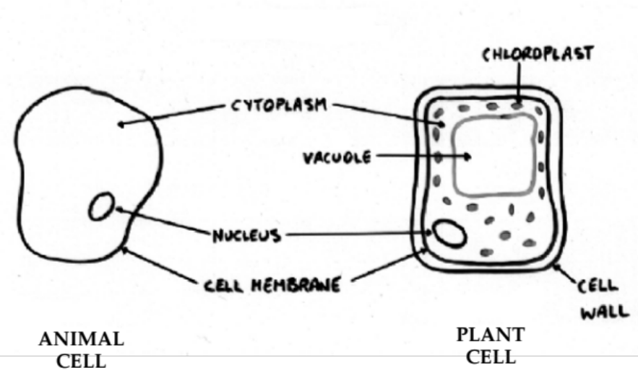

Features Common To All Cells

• Nucleus - control centre of the cell; controls all activities such as growth and reproduction of the cell.

• Cell membrane - thin layer which holds all the cell contents together; allows O₂, nutrients and H₂O to pass in and out of the cell.

• Cytoplasm - all living material inside a cell but outside the nucleus.

Differences Between Plant And Animal Cells

Plant cells have the following features. Animal cells don’t.

• Vacuole - water storage compartment which helps maintain water balance in a plant.

• Chloroplasts - contain green chlorophyll which is involved in photosynthesis (the process of making food).

• Cell wall - rigid wall made of cellulose; gives a plant its shape.

Note

Animal cells don’t have a rigid cell wall so that they can alter their shape as an animal moves.

